**BHAVAN’S B.P. VIDYA MANDIR, KORADI, NAGPUR**

**SESSION :2024 – 2025**

**Report Writing-**“**Literary Voices: A Celebration of Expression”**

Bhavan’s B. P. Vidya Mandir, Koradi organised a programme named “Literary Voices: A Celebration of Expression”, under which the First ever INTER-SCHOOL DECLAMATION COMPETITON for students was organised.

The objective of this competition was to provide a platform for high schools students. Bringing together some of the brightest orators from 27 schools in the region.

The event aimed to hone the public speaking skills of students while providing them with a platform to express their thoughts and ideas confidently.

The competition was held on 30th November 2024 at Bhavan’s B. P. Vidya Mandir, Koradi, bringing together educators along with students from various educational institutions to perform under one roof.

The esteemed chief guest for this maiden event hosted by Bhavan’s B. P. Vidya Mandir, Koradi was Dr. Sunil Kumar, Sr. Principal, Scientist and Head, CSIR, National Environment Engineering Research Institute, Nagpur.

The dignitaries on the dais were Smt. Sunanda Sonarikar, Secretary, Bharatiya Vidya Bhavan, Nagpur Kendra, Prof. Q. H. Jeevaji, Executive Committee Member, Bharatiya Vidya Bhavan, Nagpur Kendra, Smt. Annapoorni Shastri, Director, Bharatiya Vidya Bhavan, Nagpur Kendra, Smt. Anju Butani, Academic Coordinator and Manager, Bharatiya Vidya Bhavan, Nagpur Kendra and Smt. Vedika Agrawal, Parent Representative, Dr. Prantik Banerjee, Professor and Research Supervisor, Dept. of English, Hislop college, Nagpur, Smt, Asawari Shenolikar, Deputy Editor, The Hitavada, Dr. Deepshikha Mehra, HOD, Humanities, School of Humanities and Sciences, Ramdeobaba University, Nagpur and Dr. (Mrs.) Urmila Dabir, Principal, Rajkumar Kewalramani Kanya Mahavidyalaya, Nagpur, were the invited judges.

In the captivating and inspiring speech, by the chief guest, he urged the students and teachers to find their own voice, to think bigger and to inclusively develop themselves in a sustainable environment.

Dr. Prantik Banerjee, Professor and Research Supervisor, Dept. of English, Hislop college, Nagpur and Smt, Asawari Shenolikar, Deputy Editor, The Hitavada, were the esteemed judges for the Inter-School Declamation Competition.

The competition featured students of classes Std VIII to Std X allowing participants to showcase their command over language, articulation, and stage presence. Each student passionately delivered their speeches with compelling arguments, inspiring anecdotes, and eloquence.

The panel of judges, evaluated the participants on various criteria, including content, delivery, voice modulation, and body language. The competition witnessed a tight contest, as all participants demonstrated exceptional talent and dedication.

Mast Akshit Jagam from The Jain International School, bagged the first prize, followed by Miss Manushri Holey from Bhavan’s B. P. Vidya Mandir Srikrishna Nagar and Miss Antra Vyapari from Central India Public school, as 1st and 2nd runner up respectively.

The Programme was diligently organized by the meticulous planning of Principal, Miss. Sarbani Bose and the event concluded with a vote of thanks, appreciating the efforts of the organizers, teachers, and students who made the event a grand success. It served as a remarkable opportunity for young minds to explore their potential and left everyone inspired by the power of words.

The overall in charge was Smt. Poonam Tiwari, Smt. Nuzhat Qureshi delivered the Welcome speech, Smt. Jeena Joseph compared the proceedings of the Declamation event while Miss Suzanah Gormanly proposed the vote of thanks.

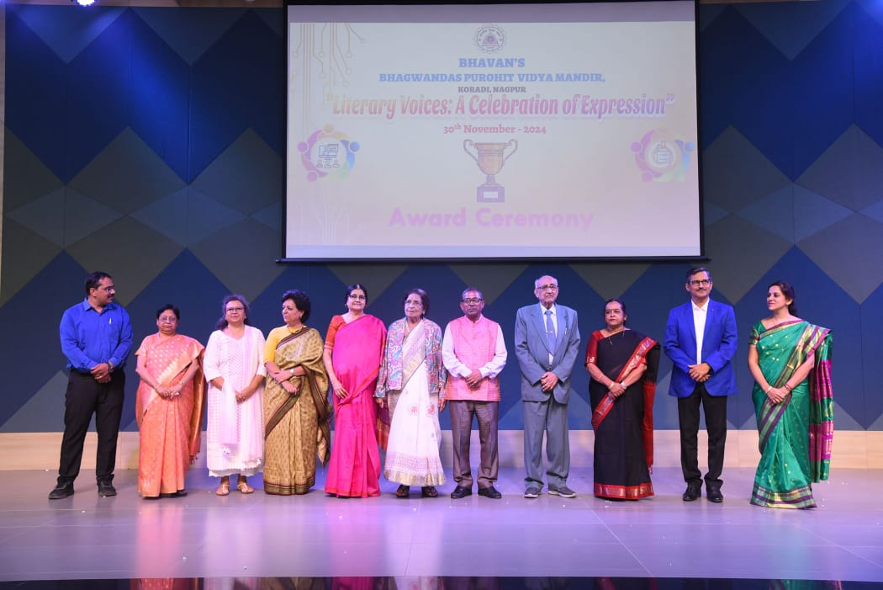

Panel of Dignitaries’ along with Our beloved Principal Miss. Sarbani Bose.

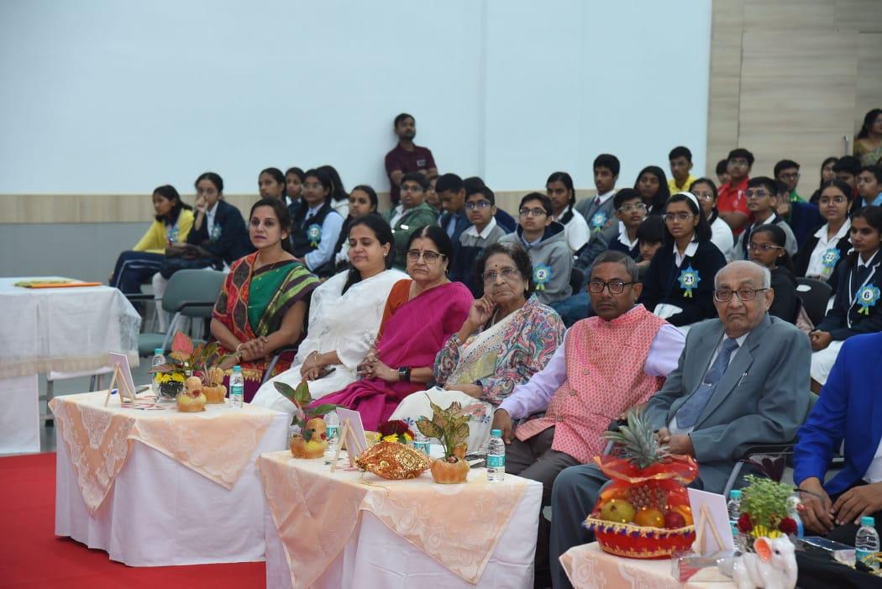

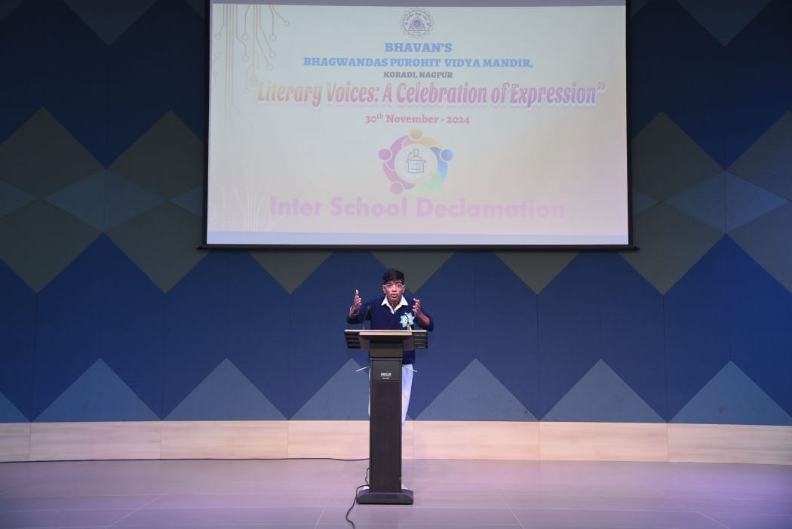

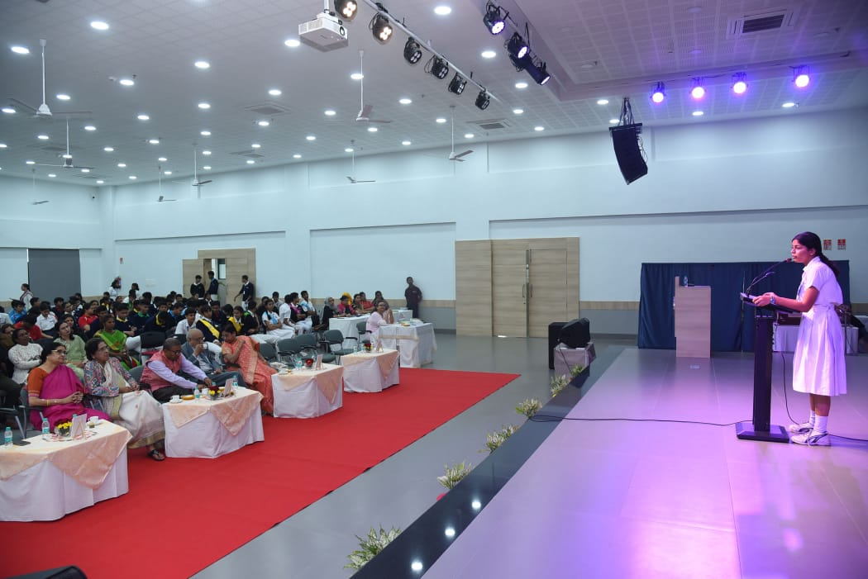

Students participating in Inter school declamation competition

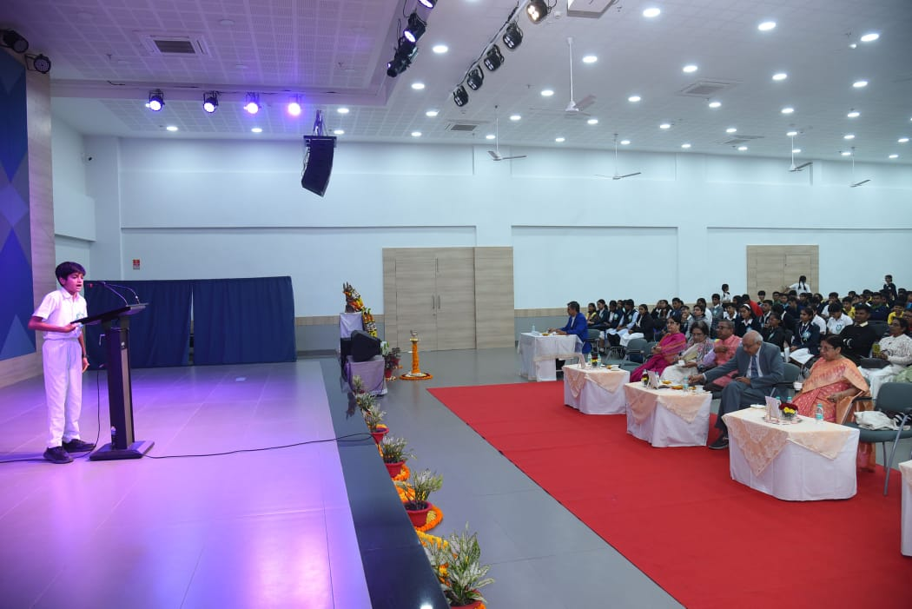

Students below receiving their awards from the panel of dignitaries.

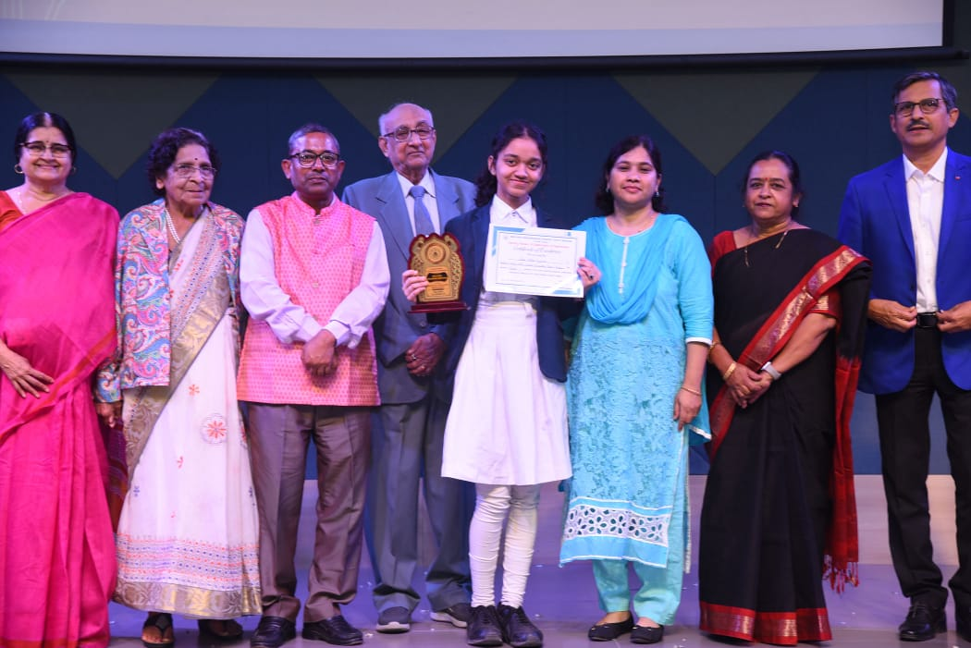

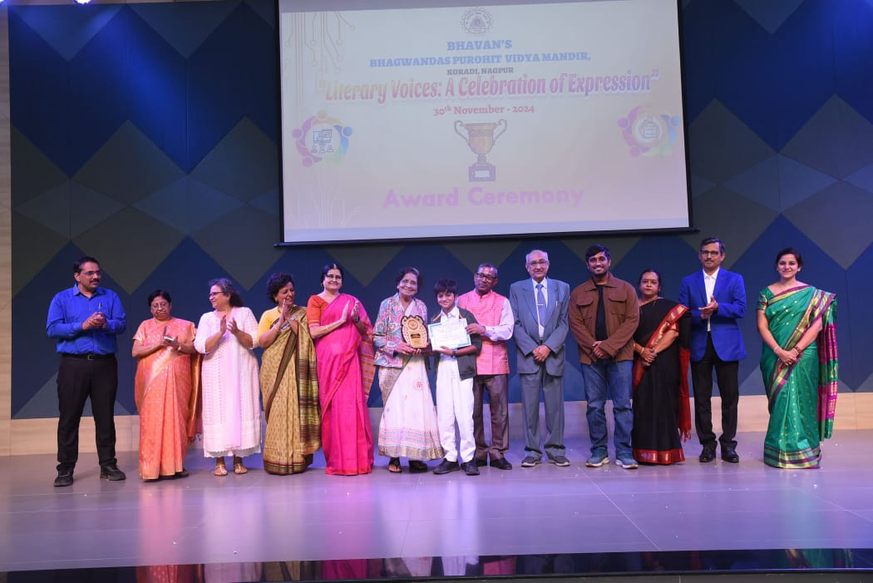

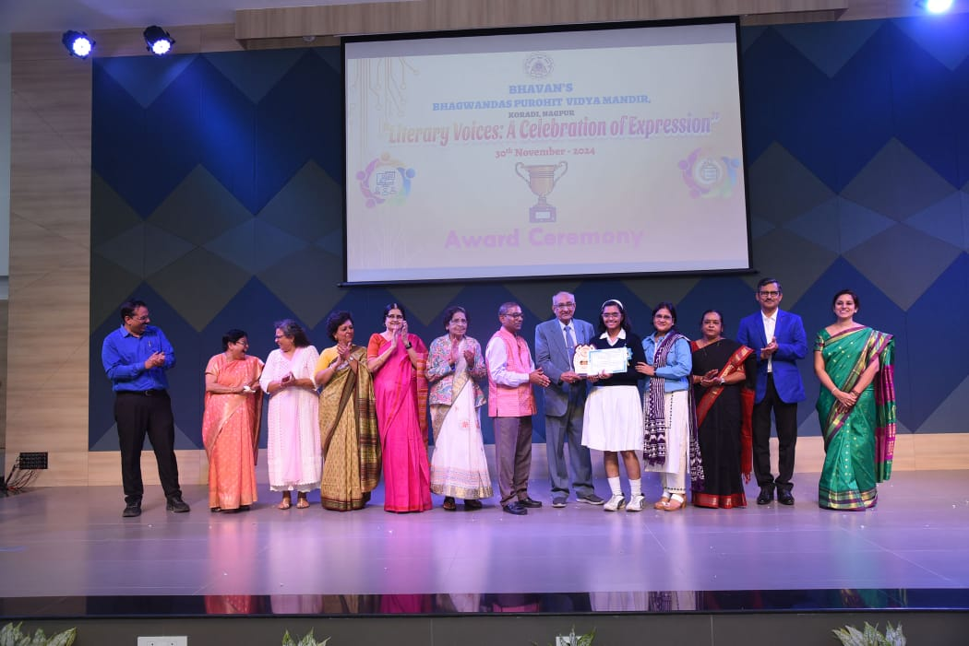

**Principal**

**Miss Sarbani Bose**